**Assignment No:-2**

Name:-Suryawanshi Sangramsingh Sambhaji

Batch:-April Date:-29/4/2024

**1. Write a program to find maximum between two numbers.**

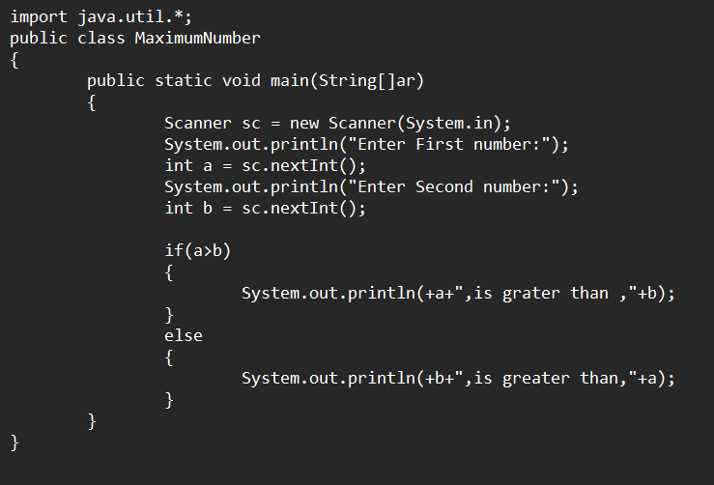

**Output:**

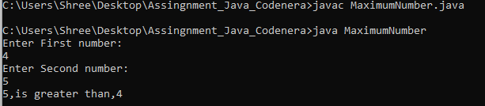

**2. Write a program to find maximum between three numbers.**

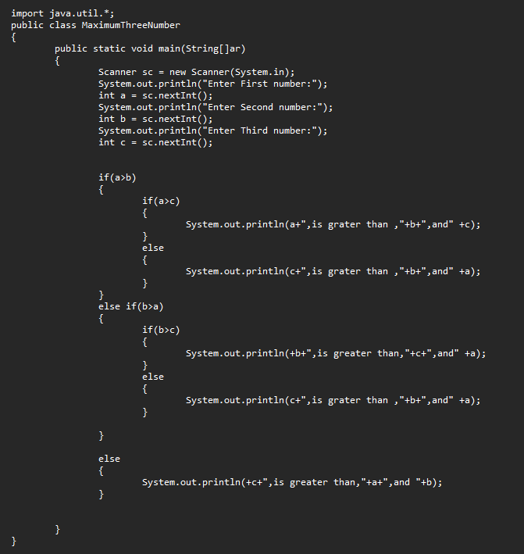

**Output:**

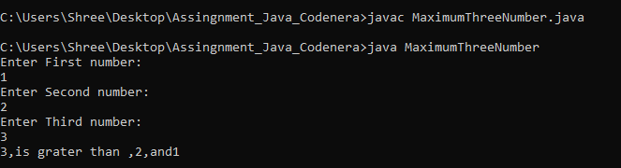

**3. Write a program to check whether a number is negative, positive or zero.**

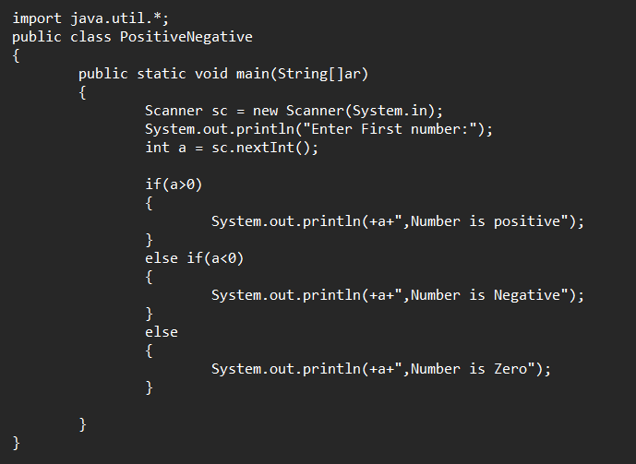**Output:**

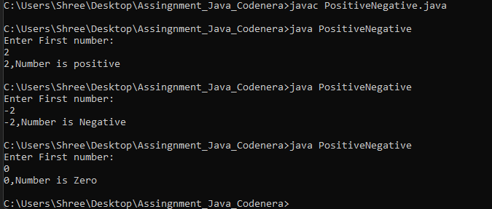

**4. Write a program to check whether a number is divisible by 5 and 11 or not.**

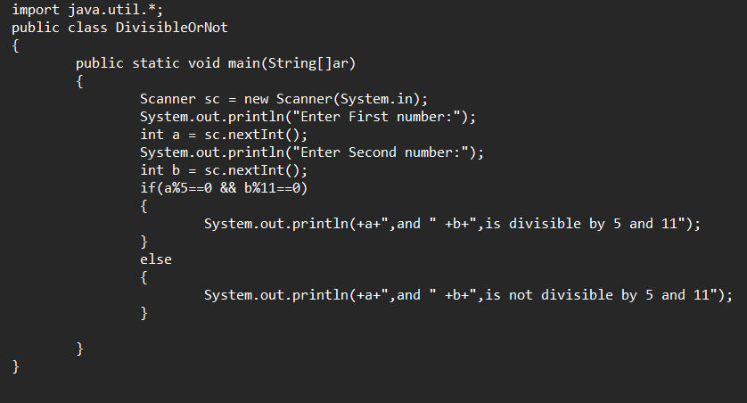**Output:**

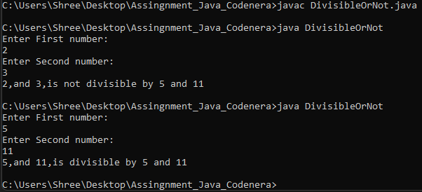

**5. Write a program to check whether a number is even or odd.**

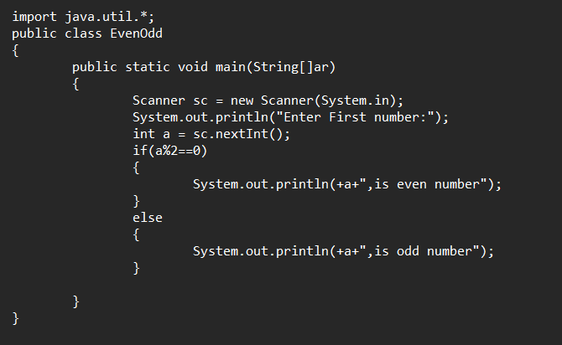**Output:**

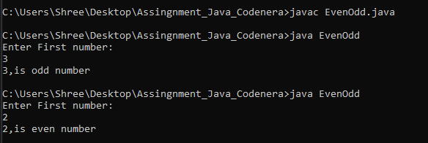

**6. Write a program to check whether a year is leap year or not.**

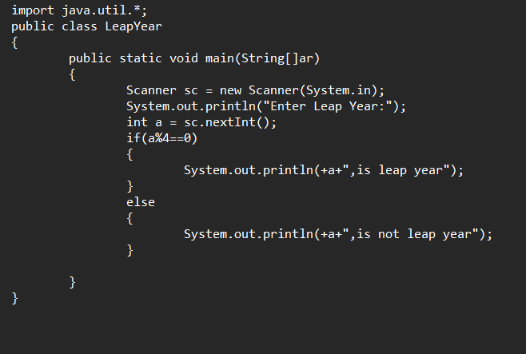**Output:**

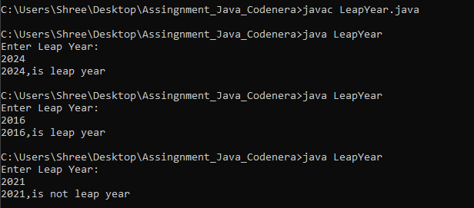

**7. Write a program to check whether a character is alphabet or not.**

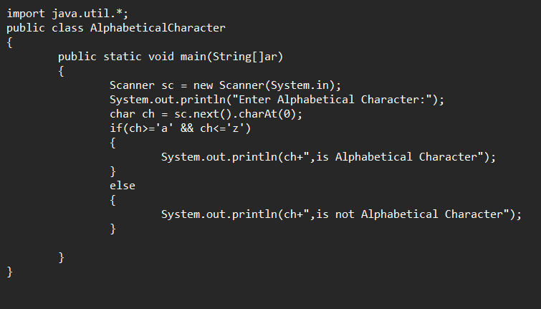**Output:**

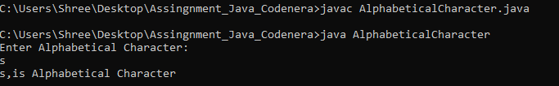

**8. Write a program to input any alphabet and check whether it is vowel or consonant.**

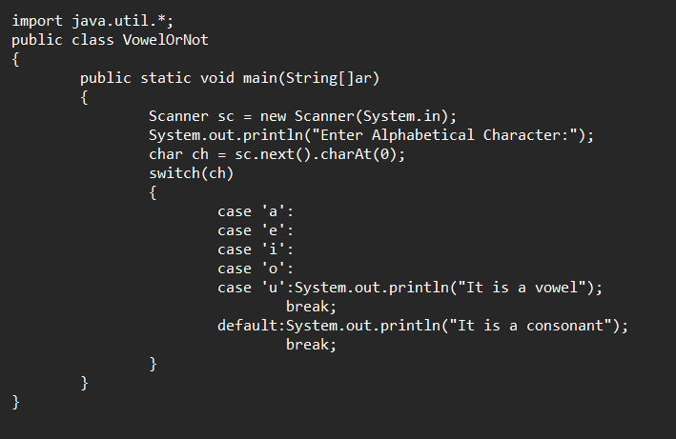 **Output:**

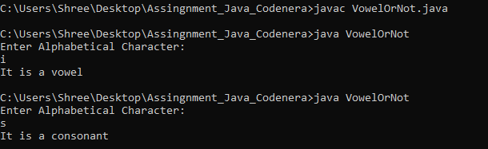

**9. Write a program to input any character and check whether it is alphabet, digit or special character.**

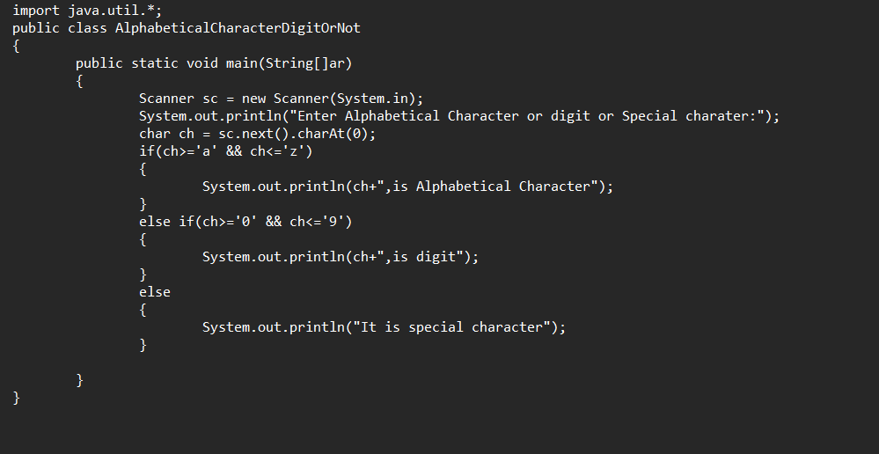 **Output:**

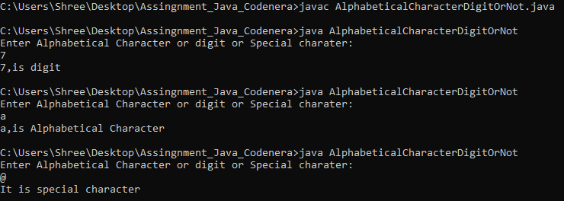

**10. Write a program to check whether a character is uppercase or lowercase alphabet.**

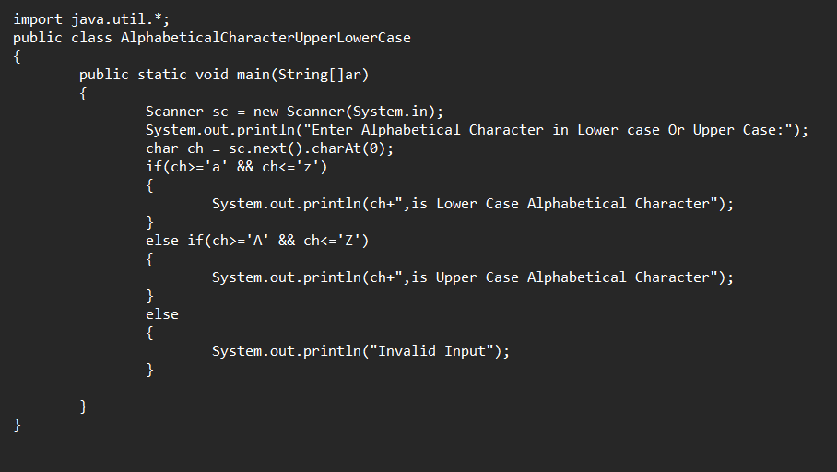 **Output:**

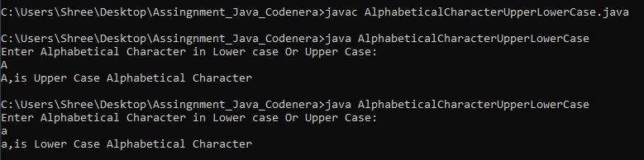

**11. Write a program to input week number and print week day.**

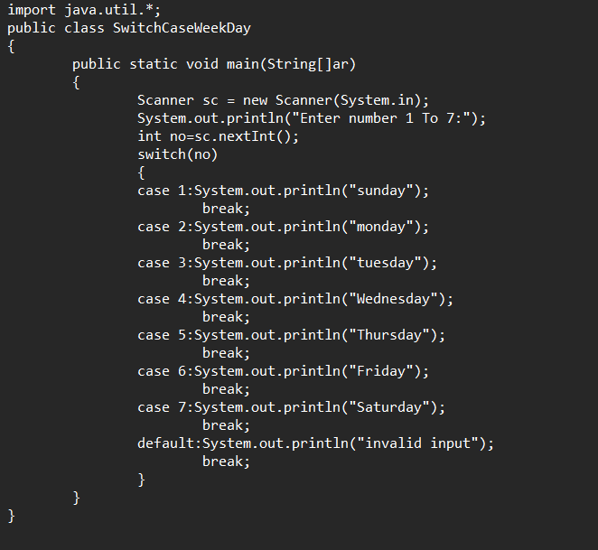

**Output:**

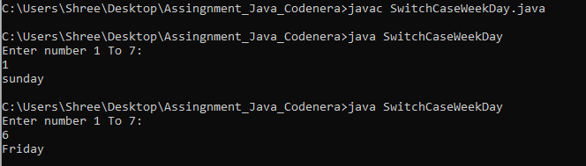

**12. Write a program to input month number and print month Name.**

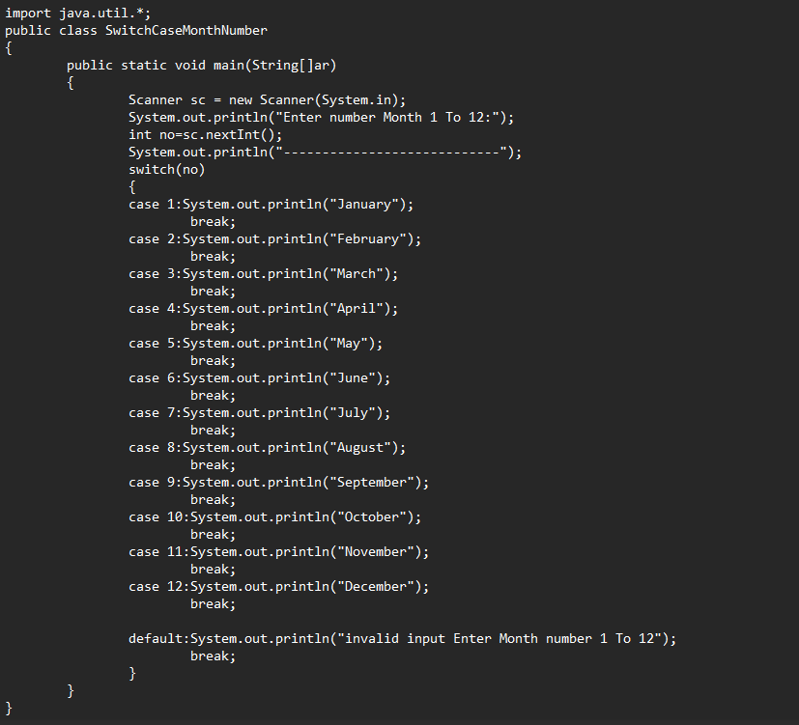

**Output:**

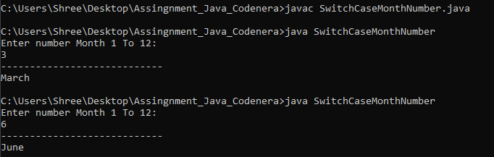

**13. Write a program to input marks of five subjects Physics, Chemistry, Biology, Mathematics and Computer. Calculate percentage and grade according to following:**

Percentage >= 90% : Grade A

Percentage >= 80% : Grade B

Percentage >= 70% : Grade C

Percentage >= 60% : Grade D

Percentage >= 40% : Grade E

Percentage < 40% : Grade F.

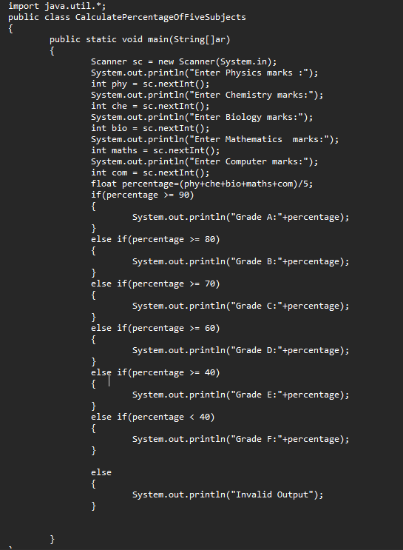

**Output:**

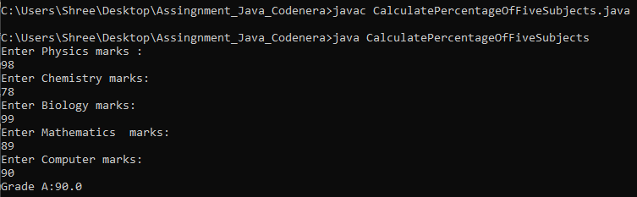

**14. A company insures its drivers in the following cases:**

If the driver is married

If the driver is unmarried, male & above 30 years of age

If the driver is unmarried, female & above 25 years of age.

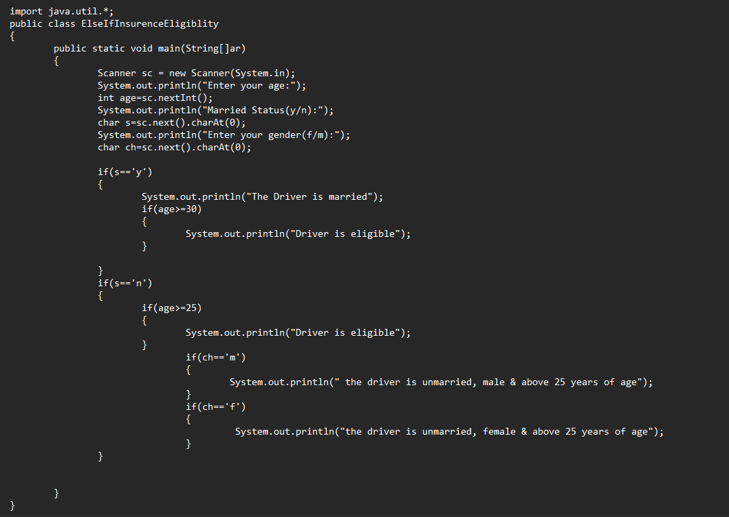

**Output:**

